HYRS Exploring Volcano Plots – July 16th

0.1_logF

width = 15,

height = 6,

dpi = 800

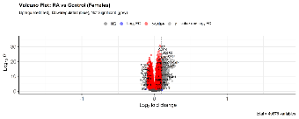

-extended width and shortened height, clearer image.

Publication 4.4:

colAlpha = 1,

cutoffLineType = 'blank',

cutoffLineCol = 'black',

cutoffLineWidth = 0.8,

hline = c(10e-20,

10e-20 * 10e-30,

10e-20 * 10e-60,

10e-20 * 10e-90),

hlineCol = c('pink', 'hotpink', 'purple', 'black'),

hlineType = c('solid', 'longdash', 'dotdash', 'dotted'),

hlineWidth = c(1.0, 1.5, 2.0, 2.5),

gridlines.major = FALSE,

gridlines.minor = FALSE)

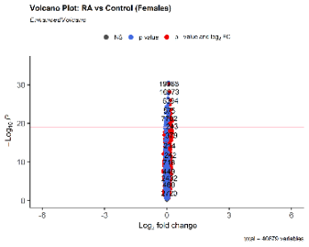

- condensed volcano plot, dot and label size is changed, cannot see non significant genes properly, presentation is no longer visually effective (because of more strigid p-value from publication script)

width = 3,

height = 10,

dpi = 200



-lengthened height, shortened width, less clear image

4.3:

shape = c(1, 4, 23, 25),

colAlpha = 1)

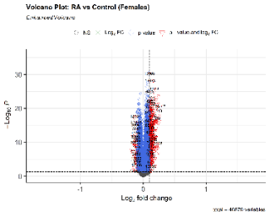

- nonsignificant vs significant genes were all represented by different shapes

shape = c(7, 8, 10, 13),

colAlpha = 1)

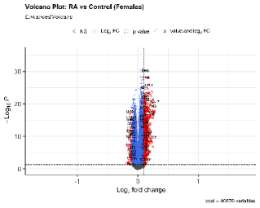

- used even more different shapes by researching the ggplot2 reference for shapes

4.4:

colAlpha = 1,

cutoffLineType = 'blank',

cutoffLineCol = 'black',

cutoffLineWidth = 0.8,

hline = c(0.02,

0.02 * 0.03,

0.02 * 0.04),

hlineCol = c('pink', 'hotpink', 'purple'),

hlineType = c('solid', 'longdash', 'dotdash'),

hlineWidth = c(1.0, 1.5, 2.0),

gridlines.major = FALSE,

gridlines.minor = FALSE)

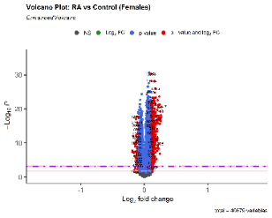

- added more threshold lines and adjusted their shape and color

4.2:

col=c('black', 'black', 'black', 'red3'),

colAlpha = 1)

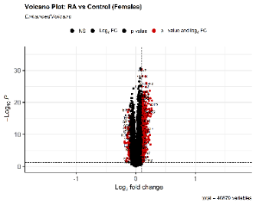

- changed the color of the dots representing genes so that only those with a significant log2fold change compared to normal are red, everything else is black

4.5:

colAlpha = 1,

legendLabels=c('Not sig.','Log (base 2) FC','p-value',

'p-value & Log (base 2) FC'),

legendPosition = 'right',

legendLabSize = 16,

legendIconSize = 5.0)

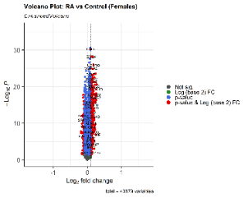

- changing the legend and its position

4.6:

colAlpha = 1,

legendPosition = 'right',

legendLabSize = 12,

legendIconSize = 4.0,

drawConnectors = TRUE,

widthConnectors = 0.75)

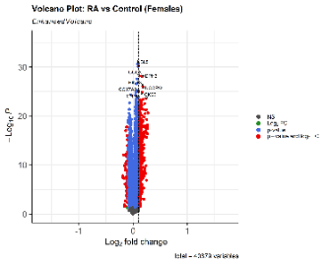

- add connectors to genes and their respective labels to make room for more labels, however this makes for a more crowded look

4.8:

labCol = 'black',

labFace = 'bold',

boxedLabels = TRUE,

colAlpha = 4/5,

legendPosition = 'right',

legendLabSize = 14,

legendIconSize = 4.0,

drawConnectors = TRUE,

widthConnectors = 1.0,

colConnectors = 'black')

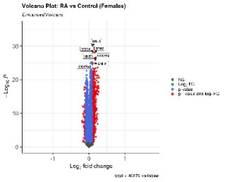

- adding boxes around gene symbols for a better look of clarity

labCol = 'red',

labFace = 'bold',

boxedLabels = TRUE,

colAlpha = 4/5,

legendPosition = 'right',

legendLabSize = 14,

legendIconSize = 4.0,

drawConnectors = TRUE,

widthConnectors = 1.0,

colConnectors = 'red')

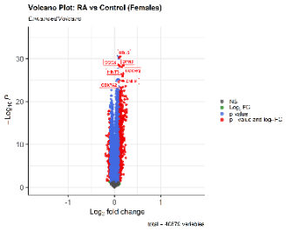

- changing gene symbol color and its box color

4.9

labCol = 'black',

labFace = 'bold',

boxedLabels = TRUE,

parseLabels = TRUE,

col = c('black', 'pink', 'purple', 'red3'),

colAlpha = 4/5,

legendPosition = 'bottom',

legendLabSize = 14,

legendIconSize = 4.0,

drawConnectors = TRUE,

widthConnectors = 1.0,

colConnectors = 'black') + coord_flip()

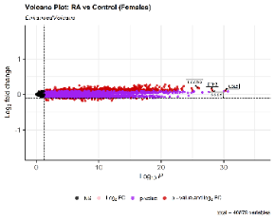

- changing color of certain variables and flipping volcano on side for a table view. (gene symbols are still boxed for an organized view)

4.14:

keyvals <- ifelse(

data$logFC < 0.1, 'royalblue',

ifelse(data$logFC > 0.1, 'gold',

'black'))

keyvals[is.na(keyvals)] <- 'black'

names(keyvals) <- rep('mid', length(keyvals))

names(keyvals)[keyvals == 'gold'] <- 'high fc'

names(keyvals)[keyvals == 'royalblue'] <- 'low fc'

shape = c(6, 4, 2, 11),

colCustom = keyvals,

colAlpha = 1,

legendPosition = 'left',

legendLabSize = 15,

legendIconSize = 5.0,

drawConnectors = TRUE,

widthConnectors = 1.0,

colConnectors = 'black',

arrowheads = FALSE,

gridlines.major = TRUE,

gridlines.minor = FALSE,

border = 'partial',

borderWidth = 1.5,

borderColour = 'black')

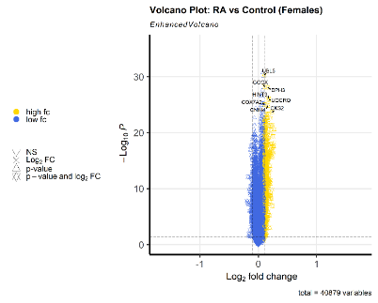

- custom color scheme with different shapes; colors represent high or low fc (up or down regulation)